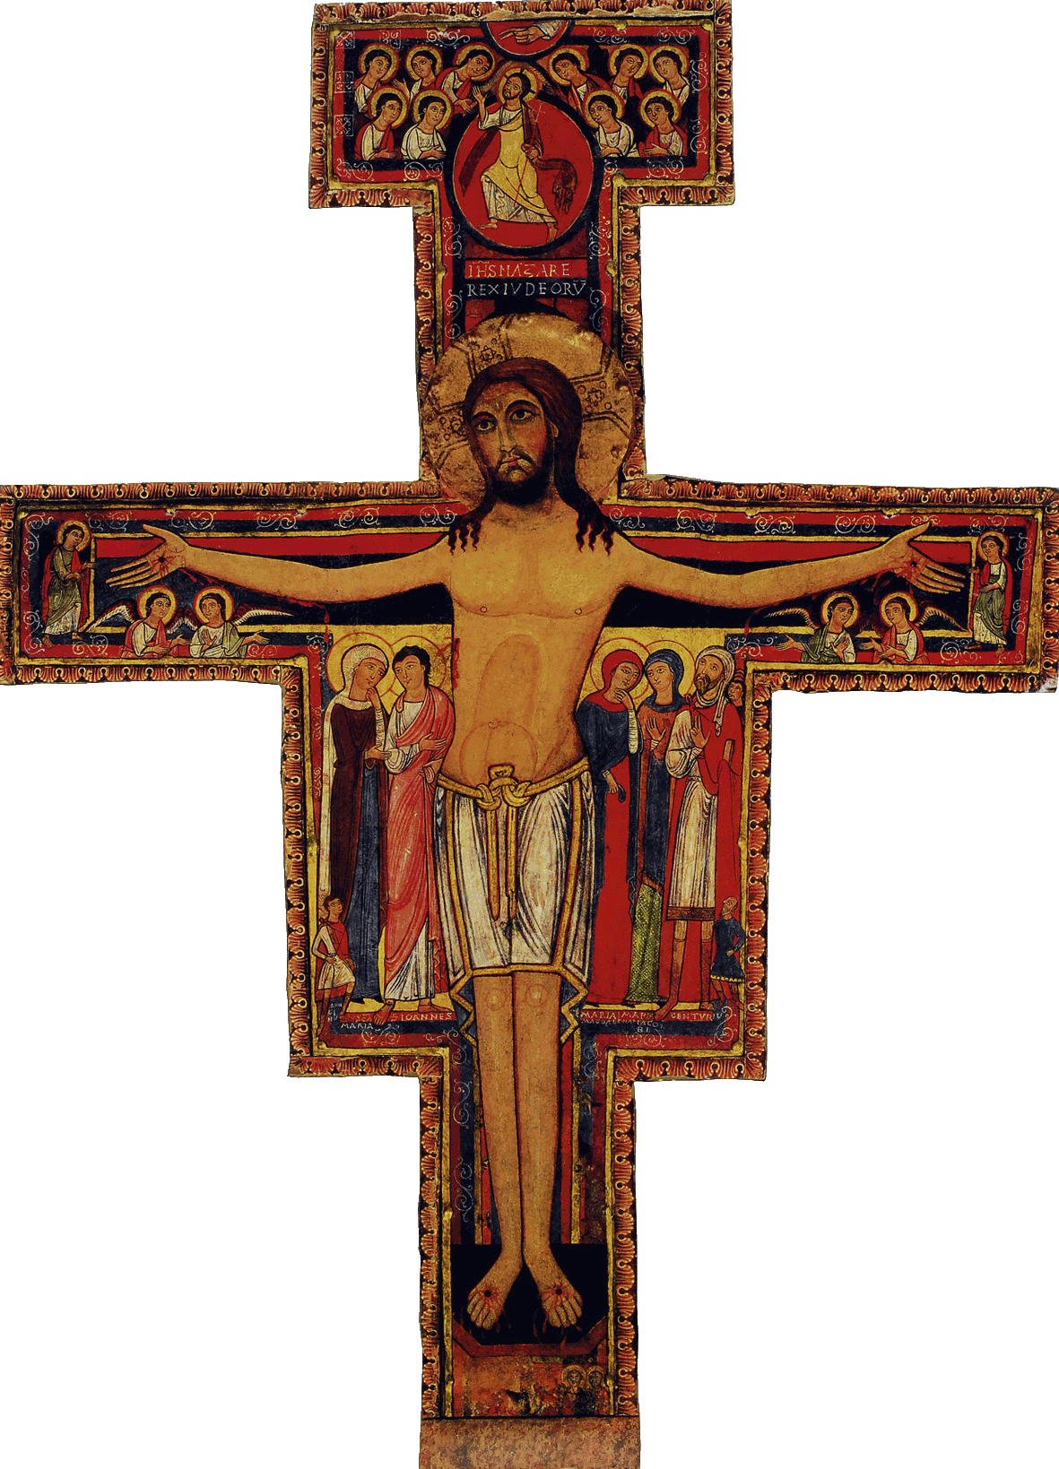

Initial Formation Program for the SFO of Canada

Personal Note

re: the Excerpts from the Contents of formation workshops

The following excerpts, that I am appending to the Initial Formation Program for the SFO of Canada, are those which are recommended and indicated in the program for each of the preceding workshops to the right of the Contents of formation: excerpts

I have prepared them in order to help the directors of formation of our local fraternities so as to facilitate their formation task as well as for the benefit of the candidates from our region. (De La Trinité).

Assuredly, I do not pretend to have found all the most adequate passages …but I have kept as criteria
- to present passages that seem to me as being most closely relating to the workshop themes
- to take into account that most of our members belong to a certain age group
- to take into consideration that our new candidates are at the outset of Franciscan spirituality
- to also take into consideration that these candidates may not necessarily have a deep Christian formation
- to not forget “ not to complicate what is simple and not simplify what seems complicated”
- to seek to make the formation content accessible to all
- that the content be presented as much as possible within 3 pages
- that the sum of these excerpts can be presented in a maximum of fifteen minutes and that it allows for a time of exchange and sharing between the members

Given that the candidate is also responsible for his or her formation and that he or she has all the leisure to comprehend its content with the help of complete documents (that can be easily photocopied and offered to all who wish to have them) in spite of this I feel at ease presenting them because they should suit you as well.

For the benefit of all, I would be grateful to anyone who can improve on these criteria and is willing to share of his or her work.

Fraternally as ever in our Father saint Francis
Micheline J. Larocque, ofs
Regional Fraternity De La Trinité

