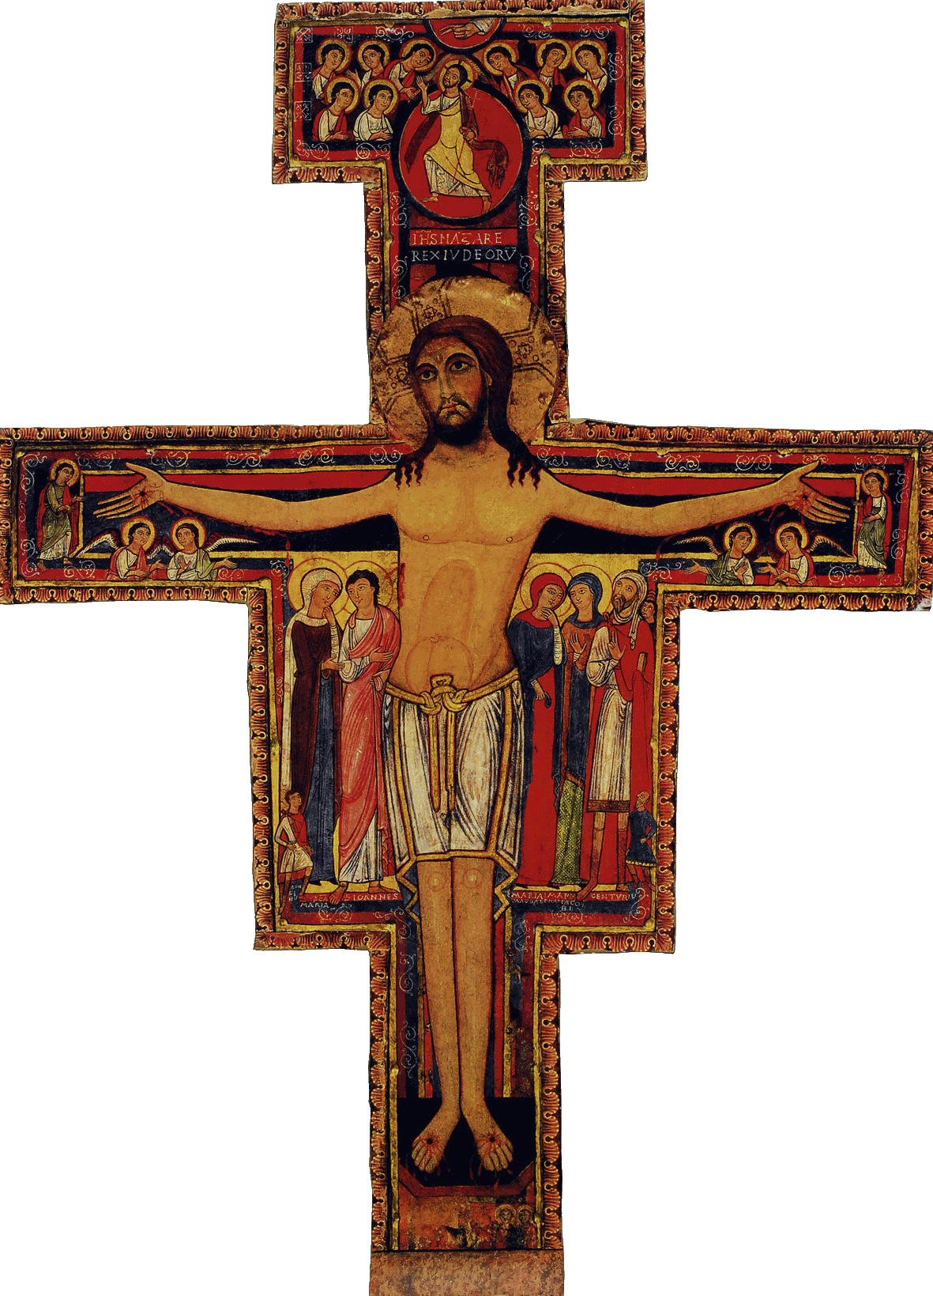

Initial Formation Program of the SFO of Canada

Workshop # 7: Mary, Inspiration for our Life

Welcome | .
Opening Prayer/Song  The Word of God/Sharing | From the Ritual, or the Liturgy of the Hours, or the Prayers of Saint Francis or other Franciscan sources  Mary at the Annunciation; the Birth of Jesus; the flight into Egypt.; at Cana; at the Passion; at Pentecost and afterwards
Articles of the Rule (Life Project)  and of the General Constitutions  Content of the Formation taken from the CIOFS Formation Manual/Sharing  Franciscan Writings | Article 9  Article 16  Formation Manual : section FRANCIS AND THE BLESSED VIRGIN MARY :  The function of the Blessed Virgin in the plan of salvation; Our Franciscan Heritage;  Franciscan Focus; Mother of the Franciscan Order  Answer, either privately, or in a group, the questions for reflection shown on page 4 of this section  Adm. 1 : On Mary‘s poverty; 2 Celano,198 : Salutation to the Virgin : Mary as protector and advocate for the Order
Pause

Other References such as Videos, CDs, DVDs, Films | Ref.: Vat. II, Const. On the Church, 52-69; Decree on The Apostolate of the Laity, 4
Optional : News/Announcements  Info. on the Church and Order | Mention and celebrate, whenever possible, the feasts (and dates) of the Virgin Mary that the Church celebrates in a special manner at certain times of the liturgical year
Formation Follow-up | In preparation for this meeting, retrace the titles that saint Francis gave to the Virgin  Write in your Journal the prayer to the Virgin that signifies « me », inspires or touches me the most
Prayer/Parting Song

