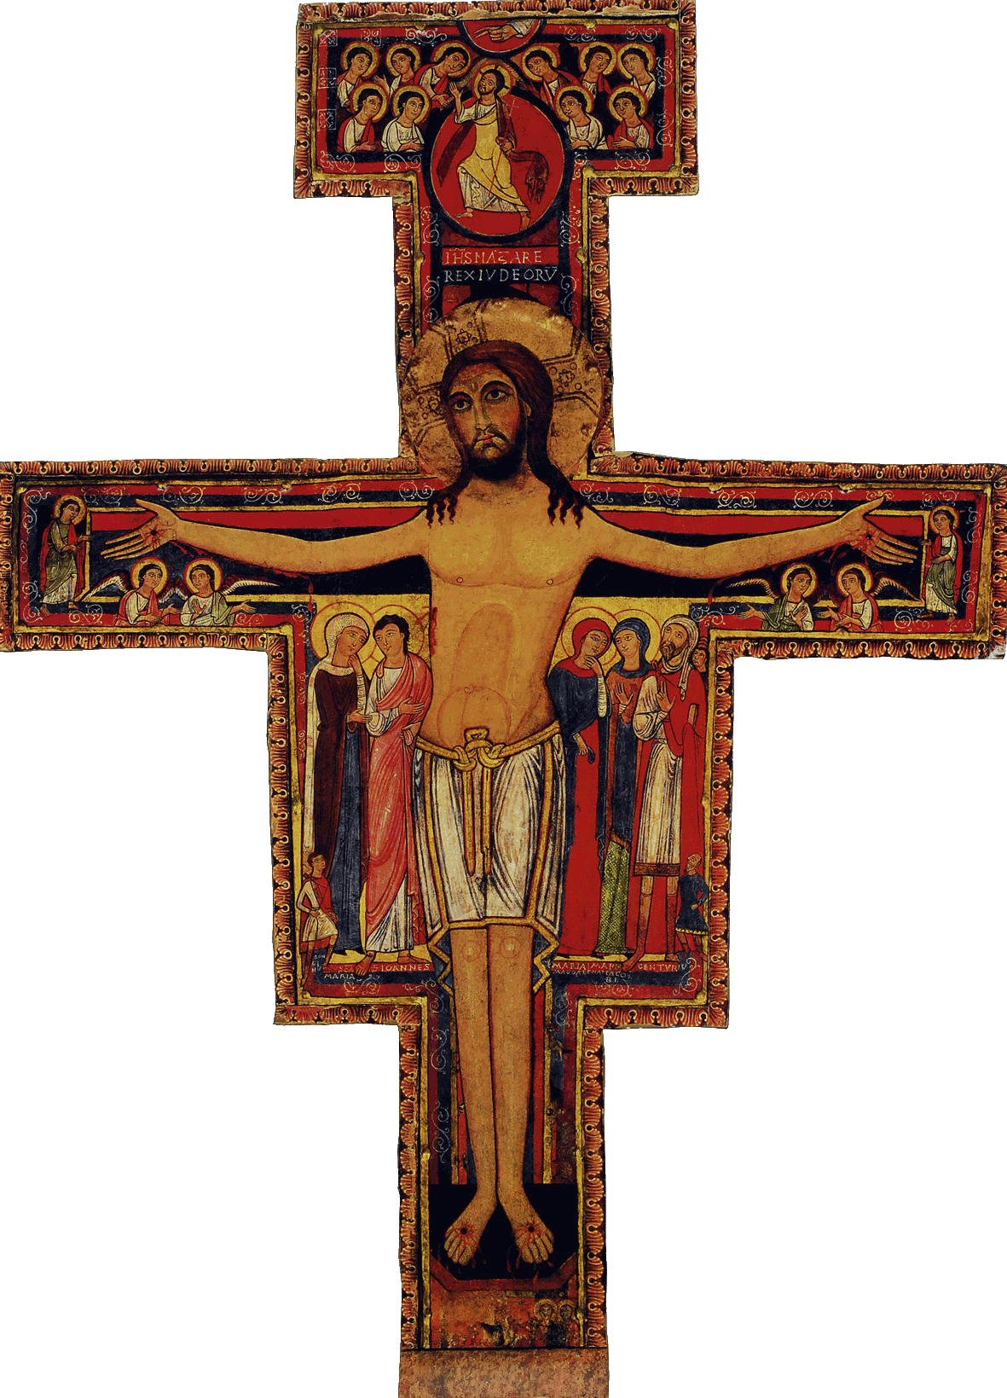

Initial Formation Program of the SFO of Canada

Workshop # 10: Invitation to life in a fraternity

Welcome

Opening Prayer/Song  The Word of God/Sharing | From the Ritual, or the Liturgy of the Hours, or the Prayers of Saint Francis or other Franciscan sources  Mark 9, 33-37; Rom. 8, 5-9. Other choices : Matt. 10,42 and 25, 40; Matt. 18,5-6 ; Luke 9, 46-48
Articles of the Rule (Life Project)  and of the General Constitutions  Content of the Formation taken from the CIOFS Formation Manual/Sharing  Franciscan Writings | Article 13 (transition article)  Article 42.4; 18. 2 , 18.3  Excerpts of Fraternity as a fundamental element of Franciscan Spirituality : Life in Fraternity : a) Fraternity of Love; b) Fraternity the Living Experience of Togetherness, Unit of Mutual Love; c) Fraternity as Sacrament of Gospel Living; d) Fraternal Service;…a Place of Conversion; The challenges of Fraternal Life…  2 Celano, 85; Saint Francis, 1st Letter to the Faithful 26; 1st Rule, ch.7, 13; 1st Rule 9, 3; Adm. 25
Pause

Other References such as Videos, CDs, DVDs, Films | In Outils pour une formation franciscaine: data sheet 4-7 : Plurality, living the differences
Optional : News/Announcements
Info. on the Church and Order

Formation Follow-up | Encourage the candidates to read the section FRATERNITY AND SAINT FRANCIS, page 10 to the end of the section  Why is the fraternity Christian and not only Franciscan?  What does the fraternity bring to one who commits to the Secular Franciscan Order?
Prayer/Parting Song

