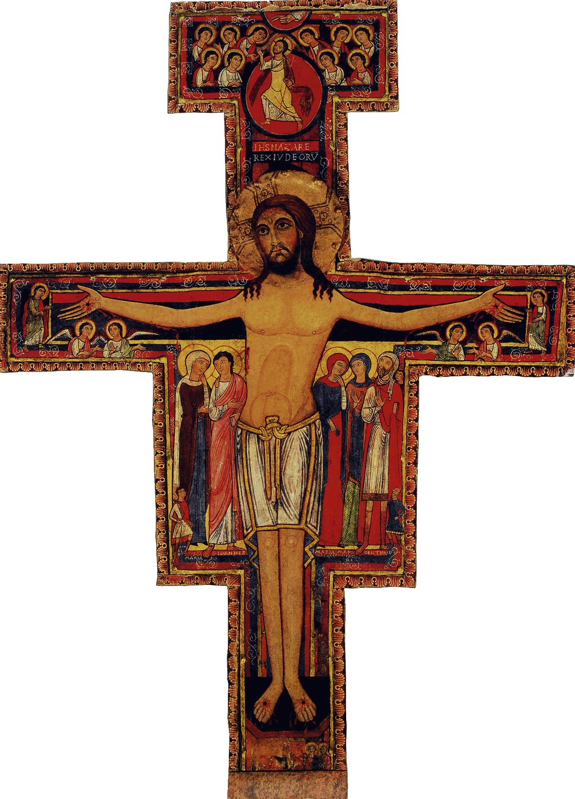

Initial Formation Program of the SFO of Canada

Workshop #1: The Nature of the SFO and the Franciscan Secular Vocation

Welcome

Opening Prayer/Song  The Word Of God /Sharing | From the Ritual, or the Liturgy of the Hours, or the Prayers of Saint Francis…  John 15, 16; 1 John 3,18; P 1, 10-11
Articles of the Rule (Life Project)  and of the General Constitutions  Contents of the Formation taken from the CIOFS Formation Manual  Sharing  Franciscan Writings | Articles 1, 2, 3  Articles 1.2 et 1.3  For Article 3 of the Rule: General Constitutions articles 4.3 and 5.1  CIOFS Manual of Formation: see section THE NATURE OF THE SECULAR FRANCISCAN ORDER: the  nature of the SFO; the Franciscan trilogy; the SFO, as an International public Association…in the world  Note : this section can also be found on the CD, in Power Point  Saint Bonaventure, Major Legend of St. Francis, Ch. 2, v.1 [ The Prophet - book II pg 536 ]
Pause

Other References such as  Videos, CDs, DVDs, Films | Acquire / read a life of saint Francis and of saint Clare; view a Video (CD; DVD) such as : Brother Sun , Sister Moon (Zefferelli) or Francis of Assisi (Michael Curtiz) or any other  Visit the Internet, search for articles on the lives of saints of the Franciscan family
Optional: News/Announcements  Info. on the Church and Order | Announce, celebrate the feasts of saint Francis; saint Clare; of the Portioncula, etc.
Formation Follow-up | Ask the candidates to answer, in a Journal, the questions prepared by the director of formation. Have them note their comments, reflections and inquiries that could be used during the sharings  Encourage the candidates to visit the following sites : www.ofsnational.ca/ ;  www.ofm-canada.org/fra/franciscains/tiers_ordre.htm
Prayer/Parting Song

